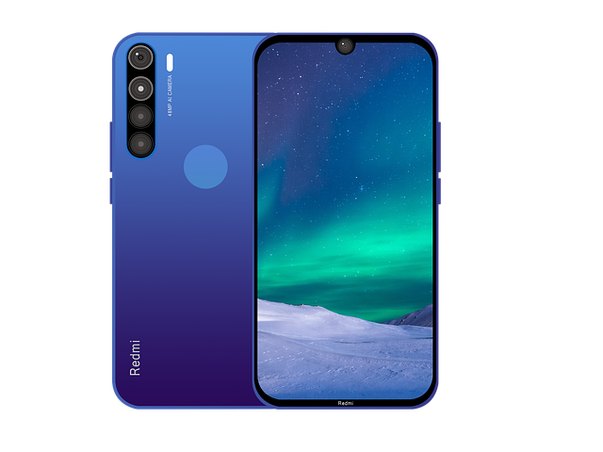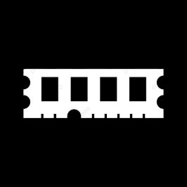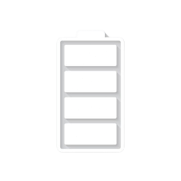

Redmi Note 8

* Processor: Qualcomm SDM665 Snapdragon 665 (11 nm)
* Front Camera: 13 MP
* Rear Camera: 48 MP
* Display:6.3 “
* NFC: NO
* Colors: Neptune Blue, Moonlight White, Space Black, Nebula Purple, Cosmic Purple
* Operating System:
* Android 11
* Charging Type: USB Type-C
* SIM:Nano-SIM
* Fingerprint: Yes
* Release Date: 2019, August 29

RAM

6

GB

ROM

128

GB

BATTERY

4000

mAh



+001-28272300-2466-2469



webmaster@cellinfo.com



A-65, ACME Co. ,

Street No. 12,

New York

Ask Me Ltd.